Minor Project Synopsis Report
SMART CCTV
Project Category: Research/Industry/Start-up/University Based Project/ Deep-tech/ IoT Based
Projexa Team Id-

Submitted in partial fulfilment of the requirement of the degree of
BACHELORS OF TECHNOLOGY
in
CSE with Specialization AI & ML (Section -A)
to
K.R Mangalam University
by

Student Name (Roll) Student Name (Roll)

Under the supervision of

Supervisor Name

Department of Computer Science and Engineering School of Engineering and Technology
K.R Mangalam University, Gurugram- 122001, India January 2026

INDEX

1. | Abstract | Page No.
2. | Introduction (description of broad topic)
3. | Motivation
4. | Literature Review
5. | Gap Analysis
6. | Problem Statement
7. | Objectives
8. | Tools/platform Used
9. | Methodology
10. | References

ABSTRACT

We are all aware of the importance of Closed-Circuit Television (CCTV) cameras. One of the most significant roles of a CCTV system is its capacity to transmit secure and timely information, which leads to increased security and situational awareness in security and operational contexts. Security cameras capture live and recorded footage that provides an actionable picture of an organization's security. Operators can use visual data to respond to an impending threat or operational problem, as well as plan ahead of time for a variety of occurrences. There is a constant rise of crimes due to various reasons like poverty, unemployment, religious conflicts, political issues, etc. There has been a significant rise in surveillance systems in India, as shown in the figure below. Even though recent decades have seen the emergence of CCTV surveillance as a mainstream crime prevention measure used around the world, one drawback of the regular CCTV cameras is that it only monitors a particular frame. Hence, in this project, we transformed the regular CCTV using artificial intelligence and machine learning algorithms, and implemented them in python, to add features like in-out movement detection-that tells whether a person is entering the area under surveillance or leaving it, and records this with time stamps, facial recognition of family members-it reads the input data and recognizes the faces added as input. It also detects noise in any frame, that is, captures any unnecessary movements in a frame, other than just monitoring the area for regular surveillance. Machine learning and AI is becoming more prevalent, as cameras are able to more accurately gather data and make predictions based on integrated analytical softwares that are being developed. While the shift to a ‘smart home’ environment is also playing its role, as consumers have easier access than ever to easy-to- install wireless devices and doorbell camera like such, to feel more secure.
KEYWORDS: CCTV, Surveillance, Machine Learning, Artificial Intelligence

INTRODUCTION

Urbanization, rapid economic liberalization, growing large-scale political turmoil, fierce conflicts, and inadequate and inappropriate policies are the basis of crime in urban areas. In addition, poverty and inequality caused by rising expectations and a sense of moral anger among some members of society contribute to increasing and increasing the level of crime. Structural adjustment programs pursued to promote economic growth, such as layoffs, shrinking civil servants, and selling civil servants, have led to increased poverty and inequality. One of the consequences of these programs is the sharp rise in unemployment, which is a major cause of crime epidemics and increases, especially in urban areas.

Not just this, Covid-19 pandemic and subsequent lockdown increased the crime rates in India itself by 28%. Unfortunately, the world we live in is becoming increasingly unsafe for all of us. We’ve seen a steady increase in the registered crime cases over the decade. Using Home Surveillance Camera we can detect crimes such as kidnapping, murder, burglary, etc. The emergence of closed-circuit television (CCTV) surveillance is a mainstream crime prevention measure used around the world. CCTV can dramatically increase the security of your property and keep your family protected. Once you get CCTV installed in your house, you no more need to worry about break- ins or burglary while you are away. Because whatever happens, it will still be recorded in your CCTV cameras. Thus, these cameras let you be, free of worry while you are away on a vacation or especially during business trips. It can very well help mitigate the crime in the first place and curb it. If a potential burglar sees your household is fully secured with CCTV in every nook and corner, it might as well put him off and because of the fear, he will deter from any crime that he earlier intended to do.

MOTIVATION

In recent decades, there have been a vast number of reasons contributing to the unexpectedly growing crimes. Urbanization, rapid economic liberalization, growing large-scale political turmoil, fierce conflicts, and inadequate and inappropriate policies can be listed as the basis of crime in urban areas. Moreover, crime rate has significantly increased due to current pandemic, and has made things worse for the security officials of all countries.

Even though we can never know the intentions of any person, but with the help of a CCTV camera, we can mitigate the risk of crime occurring around us, prevent the crime in the first place because if criminal would know that they are under surveillance, it might put them off and because of the fear, they will deter from any crime that they earlier intended to do.

In May 2021, Comparitech published a report on the use of CCTV cameras in 150 major cities across the globe. They found around 770 million cameras globally. The rising number of CCTV cameras in India is a cause of grave concern. Figure 1 shows that around 1.54 million cameras are spread among India's top 15 cities. New Delhi (5,51,500), Hyderabad (3,75,000), Chennai (2,80,000), and Indore (2,00,600) have the most surveillance cameras in the country. It is worth noting that almost 91.1% of CCTV cameras installed in the country are present only in these four cities. Also, CCTV Market Size is expected to Reach USD 46.52 Billion by 2030 at a 13.1% CAGR as suggested in a report by Market Research Future (MRFR).

The CCTVs eradicate the fear among the people in order to deter crime occurrence. Presence of the surveillance services assures the people that the surveyed areas deem more secure than the areas under no surveillance hence more people access the protected areas compared to the areas with no CCTV. The main goal of this project was to enhance the working of the currently used

CCTV cameras, add in features that would increase the security of the households, are easy to access and are very effective in monitoring and mitigating any crimes.

The project adds in features like in-out detection, noise detection and facial recognition of family members along with monitoring the frame with time stamps.

LITERATURE REVIEW

CCTV AS AN INVESTIGATIVE TOOL:

There has been extensive research on the value of CCTV for preventing crime, but little on its value as an investigative tool. The study by Matthew Ashby sought to establish how often CCTV provides useful evidence and how this is affected by circumstances, analysing 251,195 crimes recorded by British Transport Police that occurred on the British railway network between 2011 and 2015. CCTV was available to investigators in 45% of cases and judged to be useful in 29% (65% of cases in which it was available). Useful CCTV was associated with significantly increased chances of crimes being solved for all crime types except drugs/weapons possession and fraud. Images were more likely to be available for more-serious crimes, and less likely to be available for cases occurring at unknown times or in certain types of locations. Although this research was limited to offences on railways, it appears that CCTV is a powerful investigative tool for many types of crime.

INDOOR HOME SURVEILLANCE USING IOT:

The use of traditional CCTV to monitor the secured area have three limitations, which are requiring a huge volume of storage to store all the videos regardless there are intruders or not, does not notify the users immediately when there are motions detected, and users must always check the CCTV recorded videos regularly to identity any intruders. Therefore, a smart surveillance monitoring system is proposed to solve this problem by detecting intruders and capturing image of the intruder. Notifications will also be sent to the user immediately when motions are detected. This smart surveillance monitoring system only store the images of the intruders that triggered the motion sensor, making this system uses significantly less storage space.

ATM ROBBERY PREVENTION USING CCTV AND MACHINE LEARNING:

The idea if designing and implementation of the real-time ATM robbery prevention project came with the observation of real-time ATM robbery incidents around us. In this research paper by International Journal of Advanced Research, the project gives the alert at the instant of time when the thief is about to break the ATM machine.so, to overcome the drawbacks in the

existing systems in our society. Whenever the thief is bringing the tools for the robbery into the ATM or when the thief is trying to use the tool to break, the CCTV camera on the ATM sense whether the person is bringing tools using the deep learning techniques and machine learning. Here the OpenCV and TensorFlow are used as the platform and the python language is used for the deep learning technics and Keras API were used for object detection.

IDENTIFYING MOVING BODIES WITH CCTV AND ML ALGORITHMS:

In this research paper publishes by IEEE, the project aims at observing that if there is a database of facial data present then the task of recognition boils down to comparison of each and every face detected from the video with every face saved in the database. Now this process involves capturing the faces beforehand. This is actually a very tedious job, so the database of images is created (/updated) as and when new faces come into the camera view. The labelling of the faces can be done at leisure (by a human) or not be done at all. The current system once deployed does not need a database of images to start with. It creates its own collection of images, and then tracks the future occurrences of those images.

Table: Sample of Literature Review Table
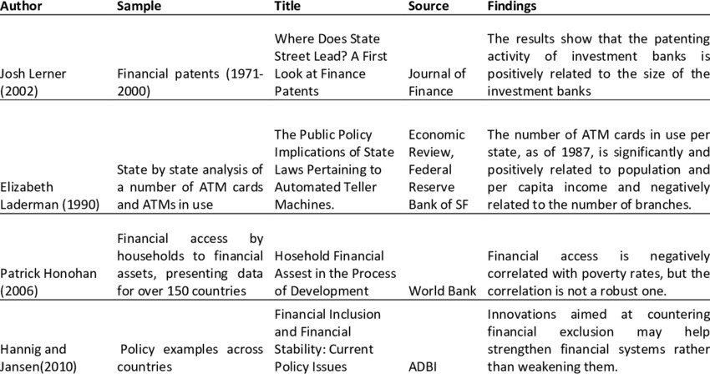

GAP ANALYSIS
From the numerous researches done for enhancement of CCTV by applying machine learning algorithms, artificial intelligence, internet of things and convolutional neural network, the resultant CCTV camera is always a stronger product than the traditional version which just monitors a particular frame. But all these projects are carried out on external safety measures such as traffic management, security of borders, bank robbery and theft, but not many researches are carried out for safety at internal household level, or, they do not provide the best set of functionalities required for a safer household. Our project covers facial recognition of family members, in and out movement detection, motion detection in frame as well as monitoring the entire frame. Hence, we have covered a good subset of requirements, all available under one place, which will help the consumers feel more secure while they are away, and the easily accessible recordings with the help of a simple GUI will add up to the pros of the project.

PROBLEM STATEMENT
The closed-circuit television (CCTV) is one of the devices used to monitor the secured area for any intruders. The presence of surveillance cameras can act as a strong deterrent to criminals and thieves, as it is possible to identify people and track their movements, using the recorded footages.

The use of traditional CCTV to monitor the secured area, but they have their own set of limitations, some of which are requiring a huge volume of storage to store all the videos regardless there are intruders or not, does not notify the users when there are motions detected, and users must always check the CCTV recorded videos regularly to identity any intruders or unusual event occurring in the area and manually check for each mishappening. This creates a need of smarter CCTV cameras, which can ease the user’s task by automating most of these tasks. Such a camera would prove to be better in terms of providing security, mitigating risks of crime, preventing crimes and also monitoring and recording the footage if the crime occurs.

OBJECTIVES

Sample Objectives
- To design and develop a scalable CCTV system that provides 24/7 surveillance coverage for critical areas, including entrances, exits, and common spaces.

- To integrate advanced motion detection and facial recognition technologies into the CCTV system to automatically identify potential security threats and reduce false alarms.

- To implement a centralized monitoring platform that allows security personnel to access live video feeds, playback recorded footage, and manage alerts from multiple cameras in real time.

- To ensure data security and privacy by utilizing encrypted data transmission and secure storage solutions for recorded footage.

- To deploy the CCTV system in the specified area and conduct extensive testing to evaluate its performance in various environmental conditions, including low light and harsh weather.
The objective is to overcome the gap from various projects and to create a smart CCTV camera for households that can add a sense of security and help mitigate the crimes. The recorded footages can be considered as evidence, provided a crime occurs. The use of machine learning algorithms is done to make it smarter, and a GUI is created using tkinter in python to make it accessible and easy to understand for its users.

Tools/Technologies Used

For this project, we have used various latest technologies which will be evaluated in this chapter with every detail of why it is used.
PROGRAMMING LANGUAGE: PYTHON

We have used Python language as it is relatively new as compared to other languages like Java, C++, etc and comes with so many features. We can perform Machine Learning, Computer Vision, Artificial Intelligence, etc with python and construction of GUI application is also easily achieved in Python.
Python is a widely used general-purpose, high level programming language. It was created by Guido van Rossum in 1991 and further developed by the Python Software Foundation. It was designed with an emphasis on code readability, and its syntax allows programmers to express their concepts in fewer lines of code. Python is a programming language that lets you work quickly and integrate systems more efficiently. There are two major Python versions: Python 2 and Python 3

Reasons for Selecting this language:
  - Short and Concise Language.
  - Easy to Learn and use.
  - Good Technical support over Internet
  - Many Packages for different tasks.
  - Run on Any Platform.
  - Modern and OOP language

METHODOLOGY

MONITOR FEATURE – SKIMAGE MODULE USED

This feature is used to find things which are stolen from the frame is visible to webcam. This means that it constantly monitors the frames and checks if an object is present in one frame and missing from the other. If some object is missing, the frame is captured along with the time stamp and recorded in the logs.

This uses Structural Similarity Index Metric (SSIM) to find the differences in the two frames. The two frames are captured first when noise was not happened and second when noise stopped happening in the frame.

SSIM is used as a metric to measure the similarity between two given images. As this technique has been around since 2004, a lot of material exists explaining the theory behind SSIM but very few resources go deep into the details, that too specifically for a gradient-based implementation as SSIM is often used as a loss function.
The Structural Similarity Index (SSIM) metric extracts 3 key features from an image:

Luminance
  - Contrast

Structure
The comparison between the two images is performed on the basis of these 3 features. Given below in the figure is the visual representation of how SSIM compares two frames with the help of these three features.

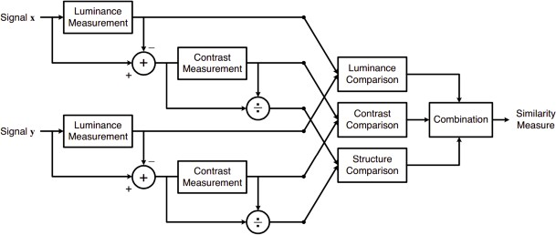
Figure 2: Architectural Diagram ( Mandatory)

This system calculates the Structural Similarity Index between 2 given images which is a value between -1 and +1. A value of +1 indicates that the 2 given images are very similar or the same while a value of -1 indicates the 2 given images are very different. Often these values are adjusted to be in the range [0, 1], where the extremes hold the same meaning.
This covers all the features, their working as well as their implementation in Python, using different modules like OpenCV, SKimage ,etc.

REFERENCES

- Securing Cyberspace: International and Asian Perspectives | Manohar Parrikar Institute for Defence Studies and Analyses. (n.d.). Retrieved July 21, 2023, from https://www.idsa.in/book/securing-cyberspace_csamuel-msharma
- Sivan, R., & Zukarnain, Z. A. (2021). Security and Privacy in Cloud-Based E-Health System. Symmetry, 13(5), Article 5. https://doi.org/10.3390/sym13050742
- Sun, W., Cai, Z., Li, Y., Liu, F., Fang, S., & Wang, G. (2018). Security and Privacy in the Medical Internet of Things: A Review. Security and Communication Networks, 2018, e5978636. https://doi.org/10.1155/2018/5978636

